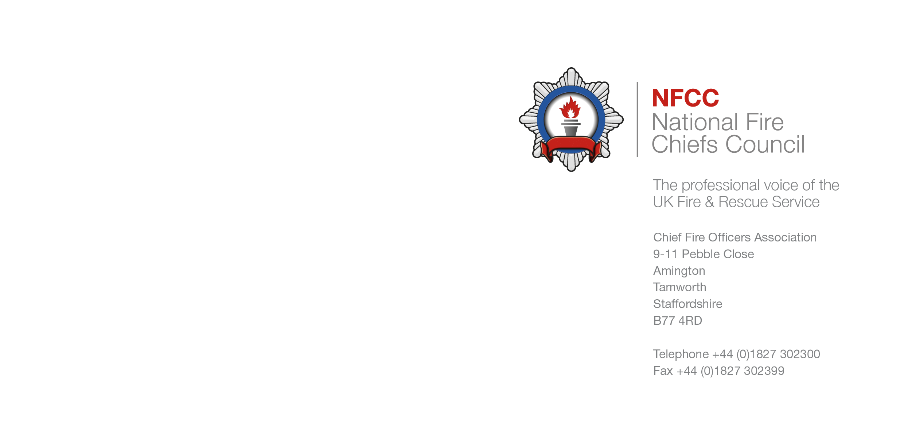

**NFCC PPE/CLOTHING COMMITTEE**

**TERMS OF REFERENCE**

1. **Background**

The National Fire Commercial Transformation Programme has so far delivered two National framework arrangements on behalf of the UK Fire and Rescue Service:

* Collaborative PPE Framework – supplying PPE to 27 FRS for over 30,000 wearers.
* National Workwear Framework – supplying uniforms and ceremonial wear. Currently in its early stages since award, 5 FRS are now signed up.

Whilst the above arrangements have been delivered through National Project Boards, represented by numerous FRS across the UK to develop and sign off the technical requirements (including accredited representatives), we still face resistance to adoption of the National arrangements.

We have more to do however. We are fast approaching the end of the life of the Collaborative PPE Framework, and we are embarking on delivering a Framework that offers Specialist PPE for our wearers, that coupled with the emerging findings from extensive research into contaminants and the increasing diverse nature of our operational services and workforce.

The NFCC PPE/Clothing Committee is therefore designed to increase collaboration and joint working across the Sector, bringing together all relevant stakeholder groups to ensure that the outputs developed by the Committee are all inclusive of all views, opinions, experience and technical expertise. This is the first Committee of its kind within this area of our business, and, it is our promise to the NFCC that we shall build on current successes to deliver fit for purpose technical outcomes for the safety of our wearers, coupled with commercial reform for the public purse.

1. **Scope**

Personal Protective Equipment (which may include some operational equipment, such as lifejackets but excludes respiratory protective devices), corporate uniform and ceremonial wear.

1. **Purpose**

The purpose of the NFCC PPE/Clothing Committee is to bring together a National group of UKFRS Representatives to work through challenges, problems statements and opportunities in relation to PPE and clothing for the benefit and safety of all our wearers. The Committee will represent National consensus, ensuring that every consideration is made to information/feedback that is gathered on behalf of the Sector. The Committee will also be the conduit between many relevant stakeholder groups as defined within the Governance section (section 5) of this document.

In summary, the Committee will be responsible for:

* Ensuring views of all stakeholders are at the core of the delivery of all outcomes and frequent and effective engagement and consultation with the Sector is maintained, promoting the benefits and encouraging take-up of all outcomes of the Committee.
* Ensure appropriate governance is in place to support the two way flow of information enabling the successful delivery of the outcomes.
* Have oversight and mitigate emerging risks and issues in relation to PPE and clothing, including commercial and ethical risks throughout the supply chain.
* Provide a clear indication to the market regarding current and future demand for PPE and clothing to ensure demand is met. This relies on collation of accurate forecast data from all Fire and Rescue Services.
* Monitor and evaluate the Committee’s performance against its purpose, which includes feedback from stakeholders and wearers across the Sector.
* Ensure effective and appropriate linkage to other NFCC Committees.
* To horizon scan for new developments in products, ways of working and standards; evaluating their benefits/impacts
* Identify research opportunities
* Delivery outcome based technical specifications specifically for all types of PPE, uniform and ceremonial wear to ensure, most importantly, that all garments provide the right level of protection for our wearers in all operational environments and scenarios.
* Identify and improve the provision of PPE and clothing for all based on an effective equality/People Impact Assessment and equality, diversity and inclusion considerations.
* Share knowledge and subject matter expertise to grow the technical capability across the Sector through ongoing open engagement.
* Engage with Industry with integrity on behalf of the Sector.
* Engage with British, European and International Standards

1. **Working principles**

‘Working principles’ are propositions or values that we as individuals and a Committee should follow and adhere to. These include:

* Committee ethos – we make decisions as a Committee, we share successes as a Committee and we learn lessons as a Committee. We constructively debate and challenge as a Committee but form a united front at CPB or any other external stakeholder meeting.
* Shared learning and transparency.
* Open and honest discussions and debate.
* Non-judgemental.
* Challenge constructively but always respectively.
* Ownership of responsibilities.
* Help and care for each other.
* All members act as Committee ambassadors and raise concerns/opportunities within the agreed governance arrangements.
* Committee members to take notes of their actions and to deliver these actions as agreed within the Committee.
* At all times represent the best interest of the UK Fire and Rescue Service, ensuring that any outcome has a direct and evidence based link with the evolving nature of our operational services – no gold plating!
* Ensure that opportunities for wider collaboration across blue light services are considered and taken forward wherever feasible.
* Ensure intrinsic link to National Operational Guidance and remains aligned to current guidance.
* Ensure frequent consultation and engagement with the wider Sector, encouraging feedback and a two-way flow of information, views and contributions towards outcomes that continue to keep our wearers safe from harm and injury.

1. **Governance**

The Committee will become a conduit with all relevant stakeholder groups as depicted below. The Committee will ensure that sufficient governance is established to support the two way flow of information enabling the successful delivery of the outcomes.

Regional Working Groups

FRS SPOCs

Industry Reps

Accredited Reps

POLICE 2025NARUOther Blue Light Services

Standards Committees

NFCC PPE/Clothing Committee

INCLUSIONWomen's NetworkAsian Network

Ops Committee/Other NFCC Committees

Commercial and Procurement Reps

National Operational Guidance

Home Office

Blue Light Commercial

DSTL

1. **Membership**

It is expected that all members act as Committee ambassadors and raise concerns/opportunities within the agreed governance arrangements. It is the responsibility of Committee members to take notes of their actions and to deliver these actions as agreed within the Committee.

The Committee will be formed of the following members:

|  |  |  |
| --- | --- | --- |
| **Member** | **Role and Region** | **Responsibility** |
| Steve Topham | Chair & National Sponsor of Collaborative PPE | Provide strategic oversight of Committee performance, ensuring that all meetings are Chaired with integrity and impartiality, encouraging constructive debates and ensuring that the views of all stakeholders are considered in any outcome. Point of escalation for key risks and issues. Ensure the benefits of the Committee are realised. |
| Brett Egan-Briers | National Technical Lead for PPE/Clothing | Provide technical leadership, sharing tacit knowledge and experience to ensure the Sector starts to benefit from increased technical capability. Ensure that there is a direct link between the Committee and all Standards Committees/Boards globally. |
| Tina Butler | National Clothing Category Lead – NFCTP | Provide strategic commercial assurance for all outcomes. Lead engagement with the Commercial and Procurement stakeholder group to develop strategies to support national collaboration to deliver the best commercial outcomes. |
| Mary Dawson | NFCTP Programme Manager | Ensure that the Committee is a fully auditable and performing forum. Develop plans in support of all working groups. Monitoring performance through delivery against agreed objectives and plans. |
| Nigel Cusack | Regional Representative[1] South East | Ensure two-way communication with FRS Single Point of Contacts (SPOCs) within the South East Region. |
| Nicol Thornton | Regional Representative London | Ensure two-way communication with the London Fire Brigade SPOC. |
| Wayne Swales | Regional Representative Eastern | Ensure two-way communication with FRS SPOCs within the Eastern Region. |
| Robin Clow | Regional Representative North East | Ensure two-way communication with FRS SPOCs within the North East Region. |
| Simon Anderson | Regional Representative North West and Northern Ireland | Ensure two-way communication with FRS SPOCs within the North West (inc NI) Region. |
| Gareth Davies | Regional Representative Wales | Ensure two-way communication with the SPOC for Wales. |
| Roddy McKinnon | Regional Representative Scotland | Ensure two-way communication with the SPOC for Scotland |
| Dave Lofthouse | Regional Representative Yorkshire and Humberside | Ensure two-way communication with FRS SPOCs within the Yorkshire and Humberside Region. |
| Steve Vincent | Regional Representative West Midlands | Ensure two-way communication with the SPOC for West Midlands. |
| Julia Skinner | Regional Representative East Midlands | Ensure two-way communication with the SPOC for East Midlands Region. |
| Matt Armstrong | Regional Representative South West | Ensure two-way communication with the SPOC for South West Region |
| Mark Hodges | National Operational Guidance (NOG) | Provide input, advice and guidance regarding NOG to ensure that all outcomes of the Committee align with the latest guidance. |
| Clive Robinson | Fire Officers Association (FOA) | Representing members of FOA, provide input, advice and guidance on behalf FOA, ensuring that the outcomes of the Committee are communicated to members and feedback brought back into the Committee for consideration. Encouraging volunteers from the group to participate in working groups to develop outcomes in response to specific problem statements. |
| Mr Jagtar Singh | AFSA National Advisor | Representing members of the AFSA, provide input advice and guidance on behalf of AFSA, ensuring that the outcomes of the Committee are communicated back to members and feedback brought back into the Committee for consideration. Encouraging volunteers from the group to participate in working groups to develop outcomes in response to specific problem statements. |
| Caroline Anderson | Women in the Fire Service (WFS) | Representing members of the WFS, provide input advice and guidance on behalf of the WFS, ensuring that the outcomes of the Committee are communicated back to members and feedback brought back into the Committee for consideration. Encouraging volunteers from the group to participate in working groups to develop outcomes in response to specific problem statements. |
| Sean Starbuck | Fire Brigades Union (FBU) | Representing members of the FBU, provide input advice and guidance on behalf of FBU, ensuring that the outcomes of the Committee are communicated back to members and feedback brought back into the Committee for consideration. Encouraging volunteers from the group to participate in working groups to develop outcomes in response to specific problem statements. |

1. **FRS Single Point of Contact (SPOC)**

The Chair has sought volunteers from each FRS to represent their respective FRS to provide technical and operational views, advice and guidance. Each SPOC will be the communication link between their respective FRS and the Regional Representative, and will ensure that all outcomes and requests for input are communicated effectively within their respective FRS, garnering an inclusive response from their colleagues. The SPOC will also support their Regional Representative to seek volunteers for participation in working groups to deliver outcomes in response to specific problem statements. A full list of SPOCS can be found in Annex A (to follow).



1. **Notable Guests**

We may, from time to time, decide as a Committee that discussions would benefit from wider input from relevant Stakeholders that are listed within Section 5, ‘Governance’. We therefore may on occasion invite representatives from any of the following stakeholder groups;

* Standards Committees (British, European and/or International)
* Industry Representatives (Suppliers within the relevant market sector)
* Home Office
* Blue Light Commercial/Police/Other Emergency Services (specifically to explore opportunities for wider collaboration or benefit from lessons learned)
* DSTL (specifically to support research and development discussion)

1. **Agenda**

The Agenda will include standing items, such as review of delivery against actions and the opportunity to propose new problem statements for discussion within Committee to determine whether any such problems should be taken forward as a particular task for a working group. We shall also review key issues and risks and ensure that all lessons learned are reported, captured, and shared across the Sector. Thereafter, the Agenda will remain flexible to enable the Committee to be pro-active and open to requests from the SPOCs. This will ensure that we continually remain focussed on any emerging issues or opportunities in real-time.

1. **Committee Papers and Transparency**

* The agenda and all papers will be distributed via email to the members one week in advance of the Committee meeting.
* A web page on the NFCC website will be developed and maintained to ensure that documentation and outputs, are made available to view by colleagues across the Sector and all suppliers and any other relevant external parties, wherever feasible and if appropriate.
* A Committee community will also be set up on Workplace to ensure that Committee members have a forum for communication either side of Committee meetings.
* Appropriate records shall also be shared with all other Stakeholders as listed within the Governance Section (5) to ensure absolute transparency. This is particularly important given our involvement with SPOCs from relevant Industry groups, we must ensure that we can evidence equitable treatment of all interested suppliers.
* These Terms of Reference shall be reviewed on an annual basis, or at any such time that circumstances require an earlier review.

1. **Out of Scope**

Operational equipment, such as torches. The Committee must however ensure interoperability with equipment that must be worn with PPE.

1. The Regional Representative is a key conduit between the Committee and their respective Region. Updates and outcomes must be communicated to SPOC’s within the Region and all feedback and views from the SPOCs must be represented at the Committee. Encouraging volunteers from their specific group of SPOCs to participate in working groups to develop outcomes in response to specific problem statements.